Fundamentals of Data Science
Assessment Tool 3
Question 3 – Retail Sales Dataset
Objective
The objective of this analysis is to perform Exploratory Data Analysis (EDA) on a retail sales dataset to understand product sales trends, revenue patterns, discount usage, and category-wise performance. The analysis aims to identify the factors that influence sales, evaluate the performance of different product categories, and uncover meaningful business insights. These findings can help organizations make informed decisions related to inventory management, pricing strategies, promotional offers, and overall business growth.

# ==========================================================
# Import Required Libraries
# ==========================================================
import pandas as pd import numpy as np import matplotlib.pyplot as plt import seaborn as sns %matplotlib inline
plt.style.use("ggplot") sns.set_theme(style="whitegrid") print("Libraries imported successfully.")
In [6]:
Libraries imported successfully.
Dataset-Description Problem-
Problem Statement
A supermarket wants to analyze product sales based on category, price, quantity sold, discount, and revenue to identify high-selling products and revenue patterns.
Dataset Features
Product_ID
Category
Price
Quantity_Sold
Discount
Revenue

Target Variable
Revenue is considered the target variable because it represents the total income generated from product sales and serves as the primary measure of business performance. It is influenced by factors such as product category, selling price, quantity sold, and discounts offered. Analyzing revenue helps identify high-performing products, evaluate the effectiveness of pricing and discount strategies, and support informed business decisions to improve sales, profitability, and overall business growth.

# ==========================================================
# Create Retail Sales Dataset
# ==========================================================
retail = {
"Product_ID":["PR01","PR02","PR03","PR04","PR05","PR06","PR07","PR08","PR09","P "PR11","PR12","PR13","PR14","PR15","PR16","PR17","PR18","PR19","P
"Category":["Grocery","Snacks","Dairy","Fruits","Vegetables","Grocery","Snacks" "Fruits","Vegetables","Grocery","Snacks","Dairy","Fruits","Vegetabl
In [8]:
"Grocery","Snacks","Dairy","Fruits","Vegetables"],
"Price":[50,30,45,60,40,80,25,55,70,35,90,20,65,75,45,100,35,50,80,30],
"Quantity_Sold":[20,35,18,25,30,15,40,16,22,28,12,45,14,20,26,10,32,19,18,35],
"Discount":[5,3,2,5,4,6,3,2,5,4,6,2,3,5,4,7,3,2,6,3],
"Revenue":[1000,1050,810,1500,1200,1200,1000,880,1540,980,1080,900,910,1500,117
} df3 = pd.DataFrame(retail) df3.head()
Out[8]:
PR01 | Grocery | 50 | 20 | 5 | 1000
PR02 | Snacks | 30 | 35 | 3 | 1050
PR03 | Dairy | 45 | 18 | 2 | 810
PR04 | Fruits | 60 | 25 | 5 | 1500
PR05 | Vegetables | 40 | 30 | 4 | 1200
# ==========================================================
# Dataset Understanding
# ==========================================================
print("Shape of Dataset:") print(df3.shape)
print("\nDataset Information:") df3.info()
print("\nData Types:") print(df3.dtypes)
In [9]:
Shape of Dataset:
(20, 6)
Dataset Information:
<class 'pandas.DataFrame'>
RangeIndex: 20 entries, 0 to 19 Data columns (total 6 columns):
# Column Non-Null Count Dtype --- ------ -------------- ---- 0 Product_ID 20 non-null str
- Category 20 non-null str
- Price 20 non-null int64
- Quantity_Sold 20 non-null int64
- Discount 20 non-null int64 5 Revenue 20 non-null int64 dtypes: int64(4), str(2) memory usage: 1.1 KB
Data Types:
Product_ID str
Category str
Price int64
Quantity_Sold int64
Discount int64 Revenue int64 dtype: object
# ==========================================================
# Data Cleaning
# ==========================================================
print("Missing Values") print(df3.isnull().sum())
print("\nDuplicate Records") print(df3.duplicated().sum())
print("\nAvailable Categories") print(df3["Category"].unique())
In [10]:
Missing Values
Product_ID 0
Category 0
Price 0
Quantity_Sold 0
Discount 0 Revenue 0 dtype: int64
Duplicate Records
0
Available Categories
<StringArray>
['Grocery', 'Snacks', 'Dairy', 'Fruits', 'Vegetables']
Length: 5, dtype: str
In [11]: # ==========================================================
# Descriptive Statistics
# ========================================================== df3.describe

20.000000 | 20.000000 | 20.000000 | 20.000000
54.000000 | 24.000000 | 4.000000 | 1114.000000
22.803509 | 9.673621 | 1.555973 | 221.416493
20.000000 | 10.000000 | 2.000000 | 810.000000
35.000000 | 17.500000 | 3.000000 | 972.500000
50.000000 | 21.000000 | 4.000000 | 1050.000000
71.250000 | 30.500000 | 5.000000 | 1200.000000
100.000000 | 45.000000 | 7.000000 | 1540.000000
In [12]: # ==========================================================
# Numerical & Categorical Analysis
# ==========================================================
print("Average Price:", df3["Price"].mean()) print("Average Quantity Sold:", df3["Quantity_Sold"].mean()) print("Average Revenue:", df3["Revenue"].mean())
print("\nCategory-wise Product Count") print(df3["Category"].value_counts())
Average Price: 54.0
Average Quantity Sold: 24.0
Average Revenue: 1114.0
Category-wise Product Count
Category
Grocery 4
Snacks 4
Dairy 4
Fruits 4
Vegetables 4
# ==========================================================
# Bar Chart - Category Distribution
# ==========================================================
Name: count, dtype: int64 In [13]:
plt.figure(figsize=(7,4)) df3["Category"].value_counts().plot(kind="bar")
plt.title("Products by Category") plt.xlabel("Category") plt.ylabel("Number of Products") plt.show()
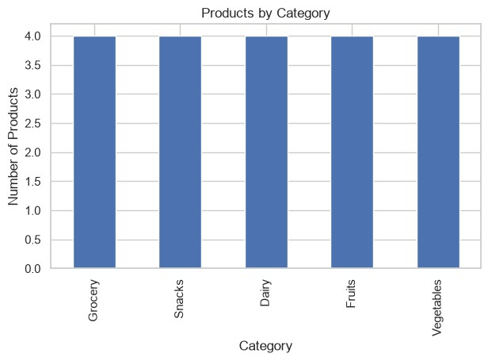
# ==========================================================
# Histogram - Revenue Distribution
# ========================================================== plt.figure(figsize=(6,4)) plt.hist(df3["Revenue"], bins=6, edgecolor="black")
plt.title("Revenue Distribution") plt.xlabel("Revenue") plt.ylabel("Frequency") plt.show()
In [14]:
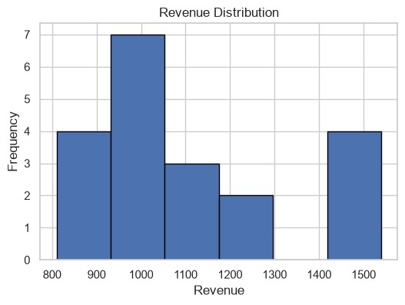
# ==========================================================
# Scatter Plot
# ========================================================== plt.figure(figsize=(6,4)) plt.scatter(df3["Price"], df3["Revenue"])
plt.title("Price vs Revenue") plt.xlabel("Price") plt.ylabel("Revenue") plt.show()
In [15]:
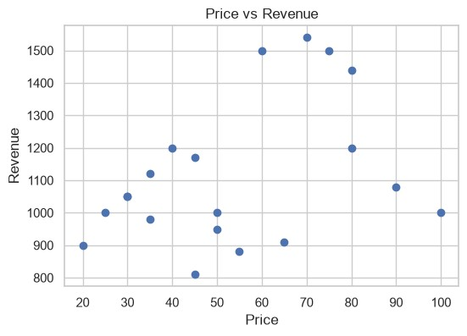
# ==========================================================
# Box Plot
# ========================================================== plt.figure(figsize=(6,4)) plt.boxplot(df3["Revenue"]) plt.title("Revenue Box Plot") plt.ylabel("Revenue") plt.show()
In [16]:
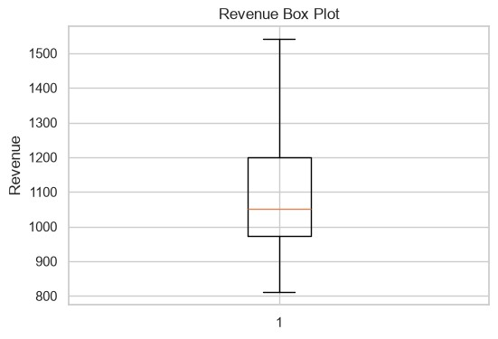
# ==========================================================
# Pie Chart
# ========================================================== plt.figure(figsize=(6,6))
df3["Category"].value_counts().plot( kind="pie", autopct="%1.1f%%"
)
plt.title("Product Category Distribution") plt.ylabel("") plt.show()
In [17]:
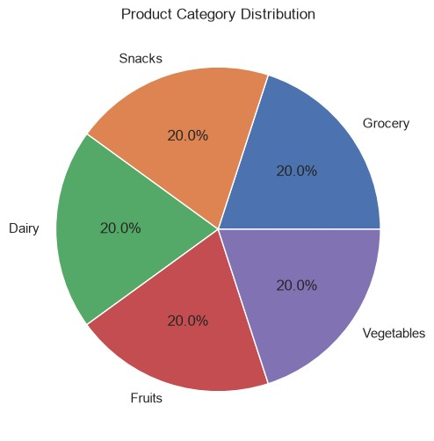
# ==========================================================
# Heatmap
# ========================================================== plt.figure(figsize=(6,4))
sns.heatmap( df3.select_dtypes(include=np.number).corr(), annot=True, cmap="coolwarm"
) plt.title("Correlation Heatmap") plt.show()
In [18]:
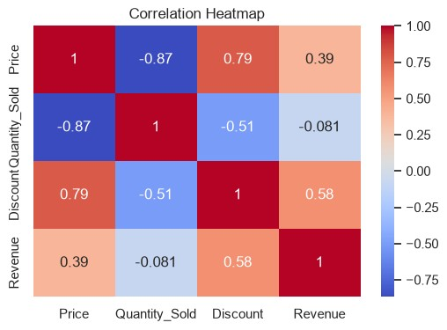
Observations
- Fruits and Grocery products generated some of the highest revenues.
- Higher-priced products do not always generate the highest revenue because quantity sold also affects revenue.
- Discounts vary across product categories and may influence sales.
- No missing values or duplicate records were found.
- Revenue is positively related to both price and quantity sold.

The Exploratory Data Analysis (EDA) shows that product price, quantity sold, and discounts have a significant impact on revenue generation. Products with higher sales volumes generally contribute more to overall revenue, while discounts can influence customer purchasing behavior and sales performance. The category-wise analysis helps identify the best-performing product groups and those that require improvement. These insights enable businesses to make informed decisions regarding inventory management, pricing strategies, promotional campaigns, and sales planning, ultimately improving profitability and overall business performance.

